Algebra 1: Unit 4, Lesson 2

- The graph of function $3x-7y=183$ is shown.
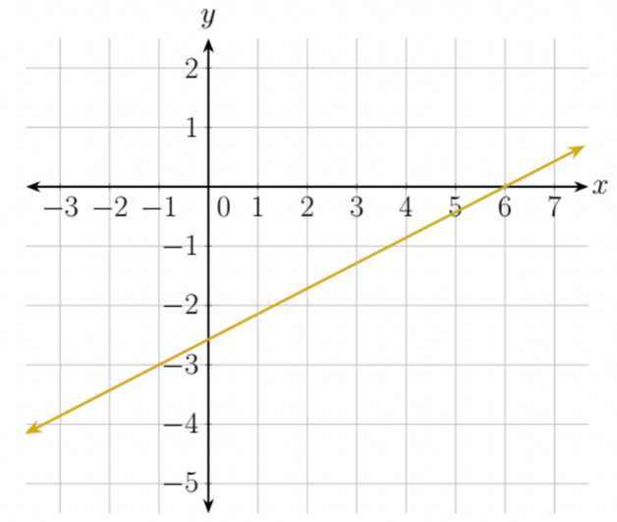
What is the $x$-intercept of $3x-7y=18$?
6

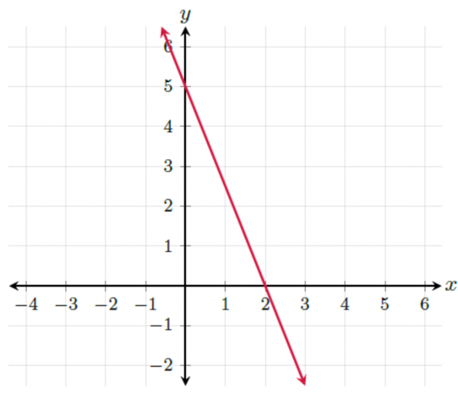
- The graph of the function $10x+4y=20$ is shown.

What are the coordinates of the $x$- intercept?
$$(0,2)$$

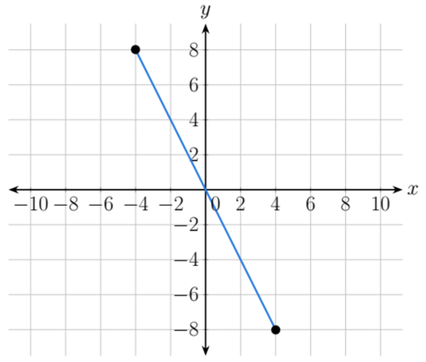
- A graph of a partial function is shown on a coordinate plane.

What is the domain of this function in interval notation?
$$[-4,4]$$

